USER GUIDE

To start off, you would need to open the terminal and open mysql by using the common mysql -u me -p. After that to access the database, you must use the command USE fest_21540095 in order to access the database containing all the information. After that you can check these tables by using the command SHOW TABLES, and the options of the tables, Award, AwardCategory, Person, Festival and Films will appear. You can view any of the information in the tables by using the command SELECT * FROM Award (or one of the tables names). It will display all the information that I have inserted onto the table. If you would like to see the information like the NULL, Data types and such for the tables, you can view them by using the command DESC Award. I have used an sql script to populate the tables, several queries for my questions, procedures, triggers and a view.

**Creating Tables**

CREATE TABLE AwardCategory (

categoryID INT NOT NULL PRIMARY KEY,

categoryName VARCHAR(100) NOT NULL,

Description VARCHAR(255)

);

CREATE TABLE Film (

FilmID INT NOT NULL PRIMARY KEY,

Director VARCHAR(100) NOT NULL,

filmName VARCHAR(100) NOT NULL,

Year INT NOT NULL,

FestivalName VARCHAR(100) NOT NULL

);

CREATE TABLE Award (

AwardID INT NOT NULL PRIMARY KEY,

filmName VARCHAR(100),

Year INT NOT NULL,

Winner VARCHAR(100) NOT NULL

);

CREATE TABLE Person (

personID INT NOT NULL PRIMARY KEY,

Name VARCHAR(100) NOT NULL,

Job VARCHAR(100) NOT NULL

);

CREATE TABLE Festival (

festival_ID INT NOT NULL PRIMARY KEY,

location VARCHAR(100) NOT NULL,

festivalName VARCHAR(100) NOT NULL

);

**Award**

INSERT INTO Award (AwardID, filmName, Year, Winner)

VALUES

(325, 'Oppenheimer', 2024, 'Christopher Nolan'),

(335, 'American Fiction', 2023, 'Cord Jefferson'),

(500, 'American Beauty', 2000, 'Sam Mendes'),

(501, 'Gladiator', 2001, 'Ridley Scott'),

(502, 'The Lord of the Rings: The Fellowship of the Ring', 2002, 'Peter Jackson'),

(503, 'Chicago', 2003, 'Rob Marshall'),

(504, 'The Lord of the Rings: The Return of the King', 2004, 'Peter Jackson'),

(505, 'The Aviator', 2005, 'Martin Scorsese'),

(506, 'Brokeback Mountain', 2006, 'Ang Lee'),

(507, 'Dreamgirls', 2007, 'Bill Condon'),

(508, 'No Country for Old Men', 2008, 'Coen Brothers'),

(510, 'The Curious Case of Benjamin Button', 2009, 'David Fincher'),

(511, 'Avatar', 2010, 'James Cameron'),

(513, 'The King\'s Speech', 2011, 'Tom Hooper'),

(514, 'Hugo', 2012, 'Martin Scorsese'),

(515, 'Lincoln', 2013, 'Steven Spielberg'),

(516, 'American Hustle', 2014, 'David O. Russell'),

(518, 'Birdman or (The Unexpected Virtue of Ignorance)', 2015, 'Alejandro González Iñárritu'),

(520, 'The Revenant', 2016, 'Alejandro González Iñárritu'),

(521, 'La La Land', 2017, 'Damien Chazelle'),

(522, 'The Shape of Water', 2018, 'Guillermo del Toro'),

(523, 'Roma', 2019, 'Alfonso Cuarón'),

(525, 'Joker', 2020, 'Todd Phillips'),

(526, 'Mank', 2021, 'David Fincher'),

(527, 'The Power of the Dog', 2022, 'Jane Campion');

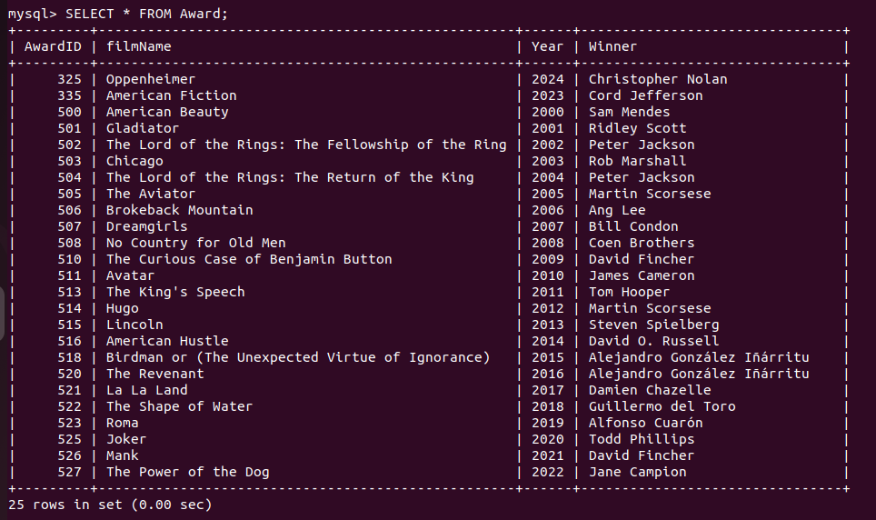

This is what my Award table looks like.

**Award Categroy**

INSERT INTO AwardCategory (categoryID, categoryName, Description)

VALUES

(425, 'Best Picture', 'Award category is for the films that have been voted the best movie by the judges'),

(435, 'Best Director', 'This award is given to the director who is voted as the best by the judges'),

(445, 'Best Actor', 'This award is given to the actor who has portrayed his role best according to the majority of judges chosen by the event');

**Person**

INSERT INTO Person (personID, Name, Job)

VALUES

(5, 'Christopher Nolan', 'Director'),

(7, 'Cord Jefferson', 'Director'),

(8, 'Cillian Murphy', 'Actor'),

(11, 'Oppenheimer', 'Film'),

(12, 'American Fiction', 'Film');

**Festival**

INSERT INTO Festival (festival_ID, location, festivalName)

VALUES

(225, 'Cannes. France', 'Cannes Film Festival'),

(245, 'Los Angeles, USA', 'Oscars'),

(255, 'Toronto, Canada', 'Toronto International Film Festival');

**Films**

INSERT INTO Film (FilmID, Director, filmName, Year, FestivalName)

VALUES

(122, 'Martin Scorsese', 'Killers of the Flower Moon', 2023, 'Cannes Film Festival'),

(123, 'Celine Song', 'Past Lives', 2023, 'Oscars'),

(124, 'Greta Gerwig', 'Barbie', 2023, 'Oscars'),

(125, 'Christopher Nolan', 'Oppenheimer', 2023, 'Oscars'),

(135, 'Cord Jefferson', 'American Fiction', 2023, 'Toronto International Film Festival'),

(136, 'Alexander Payne', 'The Holdovers', 2023, 'Toronto Film Festival'),

(145, 'Justine Triet', 'Anatomy of a Fall', 2023, 'Cannes Film Festival'),

(146, 'Guillermo del Toro', 'The Shape of Water', 2018, 'Oscars'),

(147, 'Christopher Nolan', 'Dunkirk', 2018, 'Oscars'),

(148, 'Jordan Peele', 'Get Out', 2018, 'Oscars'),

(149, 'Alfonso Cuarón', 'Roma', 2018, 'Toronto International Film Festival'),

(150, 'Barry Jenkins', 'If Beale Street Could Talk', 2018, 'Toronto International Film Festival'),

(151, 'Peter Farrelly', 'Green Book', 2018, 'Toronto International Film Festival'),

(152, 'Hirokazu Kore-eda', 'Shoplifters', 2018, 'Cannes Film Festival'),

(153, 'Spike Lee', 'BlacKkKlansman', 2018, 'Cannes Film Festival'),

(154, 'Nadine Labaki', 'Capernaum', 2018, 'Cannes Film Festival'),

(155, 'Bong Joon-ho', 'Parasite', 2019, 'Oscars'),

(156, 'Sam Mendes', '1917', 2019, 'Oscars'),

(157, 'Todd Phillips', 'Joker', 2019, 'Oscars'),

(158, 'Taika Waititi', 'Jojo Rabbit', 2019, 'Toronto International Film Festival'),

(159, 'Greta Gerwig', 'Little Women', 2019, 'Toronto International Film Festival'),

(160, 'Bong Joon-ho', 'Parasite', 2019, 'Toronto International Film Festival'),

(161, 'Bong Joon-ho', 'Parasite', 2019, 'Cannes Film Festival'),

(162, 'Pedro Almodóvar', 'Pain and Glory', 2019, 'Cannes Film Festival'),

(163, 'Quentin Tarantino', 'Once Upon a Time in Hollywood', 2019, 'Cannes Film Festival'),

(164, 'Chloé Zhao', 'Nomadland', 2020, 'Oscars'),

(165, 'Emerald Fennell', 'Promising Young Woman', 2020, 'Oscars'),

(166, 'David Fincher', 'Mank', 2020, 'Oscars'),

(167, 'Regina King', 'One Night in Miami', 2020, 'Toronto International Film Festival'),

(168, 'Kornél Mundruczó', 'Pieces of a Woman', 2020, 'Toronto International Film Festival'),

(169, 'Chloé Zhao', 'Nomadland', 2020, 'Toronto International Film Festival'),

(170, 'Spike Lee', 'Da 5 Bloods', 2020, 'Cannes Film Festival'),

(171, 'Thomas Vinterberg', 'Another Round', 2020, 'Cannes Film Festival'),

(172, 'Maiwenn', 'DNA', 2020, 'Cannes Film Festival'),

(173, 'Chloé Zhao', 'Nomadland', 2021, 'Oscars'),

(174, 'David Fincher', 'Mank', 2021, 'Oscars'),

(175, 'Lee Isaac Chung', 'Minari', 2021, 'Oscars'),

(176, 'Regina King', 'One Night in Miami', 2021, 'Toronto International Film Festival'),

(177, 'Kornél Mundruczó', 'Pieces of a Woman', 2021, 'Toronto International Film Festival'),

(178, 'Chloé Zhao', 'Nomadland', 2021, 'Toronto International Film Festival'),

(179, 'Julia Ducournau', 'Titane', 2021, 'Cannes Film Festival'),

(180, 'Wes Anderson', 'The French Dispatch', 2021, 'Cannes Film Festival'),

(181, 'Leos Carax', 'Annette', 2021, 'Cannes Film Festival'),

(182, 'Jane Campion', 'The Power of the Dog', 2022, 'Oscars'),

(183, 'Ryūsuke Hamaguchi', 'Drive My Car', 2022, 'Oscars'),

(184, 'Paul Thomas Anderson', 'Licorice Pizza', 2022, 'Oscars'),

(185, 'Denis Villeneuve', 'Dune', 2022, 'Toronto International Film Festival'),

(186, 'Jane Campion', 'The Power of the Dog', 2022, 'Toronto International Film Festival'),

(187, 'Ryūsuke Hamaguchi', 'Drive My Car', 2022, 'Toronto International Film Festival'),

(188, 'Nadav Lapid', 'Ahed\'s Knee', 2022, 'Cannes Film Festival'),

(189, 'Jacques Audiard', 'Paris, 13th District', 2022, 'Cannes Film Festival'),

(190, 'Nanni Moretti', 'Three Floors', 2022, 'Cannes Film Festival');

Implement the yellow highlighted information in mysql to input commands. The orange information is used for calling.

Questions

**What are the names of the directors in the awards?**

SELECT name

FROM Person

WHERE Job = ‘director’

**Find the location of the Oscars**

SELECT Location

FROM Festival

WHERE festivalName = ‘Oscars’

**What movies are in the released after the year 2020?**

SELECT filmName

FROM Film

WHERE Year > 2020;

**What are the names of movies that start with an ‘C’**

SELECT Director

FROM Film

WHERE Director LIKE ‘C%’

**Use INNER JOIN to retrieve the filmname from Award and display the festival name and director from film table**

SELECT Award.filmName, Film.festivalName, Film.Director

FROM Award INNER JOIN Film ON

Award.filmName = film.filmName

**How many films are nominated?**

SELECT Film.FestivalName, COUNT(*) AS NumberOfFilmsNominated

FROM FIlm

INNER JOIN Festival ON FIlm.FestivalName = Festival.festivalName

GROUP BY FIlm.FestivalName

ORDER BY NumberOfFilmsNominated DESC;

4.

**Procedure to get films by director name**

DELIMITER //

CREATE PROCEDURE GetFilmsByDirector( IN directorName VARCHAR(100)

)

BEGIN

SELECT * FROM FIlm WHERE Director = directorName;

END //

DELIMETER //

CALL GetFilmsByDirector

**Procedure to get films by year**

DELIMITER //

CREATE PROCEDURE GetFilmsByYear( IN releaseYear INT

)

BEGIN

SELECT * FROM FIlm WHERE Year = releaseYear;

END //

DELIMITER;

CALL GetFilmsByYear

**Trigger to make the year always 1929**

CREATE TRIGGER BeforeInsertFilm

BEFORE INSERT ON Film

FOR EACH ROW

BEGIN

SET NEW.year = IF(NEW.year <1929, 1929, NEW.year);

END //

DELIMITER;

**View Person Detials**

CREATE VIEW PersonDetails AS

SELECT personID, Name, Job

FROM PERSON;

SELECT * FROM PersonDetails